EXPT NO: 6 Implementation of Ensemble Techniques (Bagging, Boosting , DATE:18.3.26 Random Forest, Stacking) and Handling Class Imbalance (SMOTE)

SCENARIO1: BAGGING – DIABETES
ACCURACY COMPARISON:
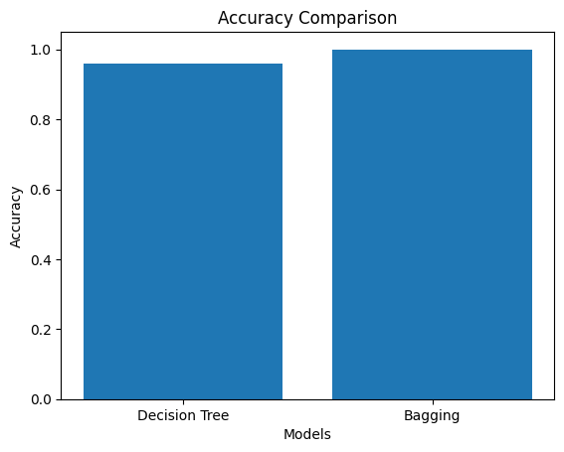
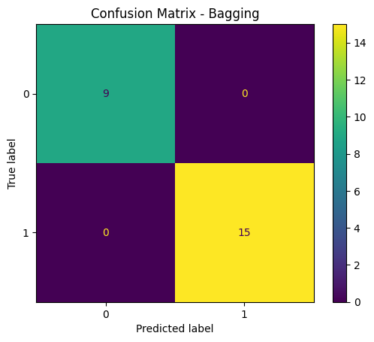
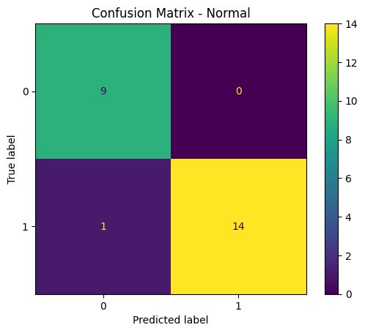

SCENARIO2: Boosting-AdaBoost , Gradient Boosting-CHURN

ROC CURVE:
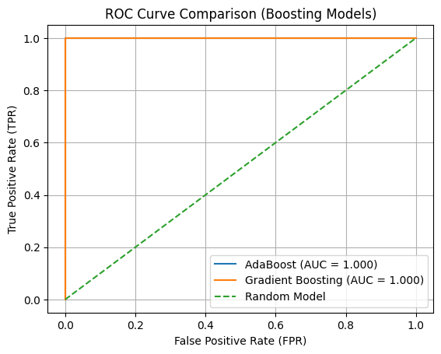
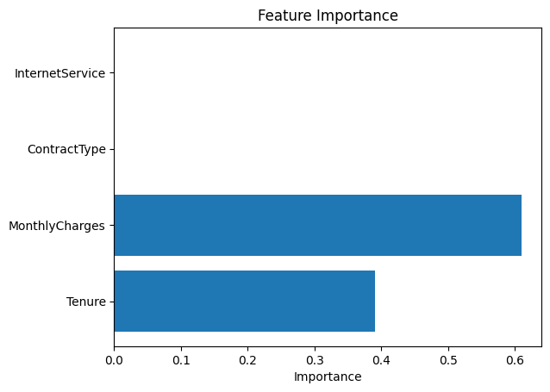

SCENARIO 3: RANDON FOREST – INCOME
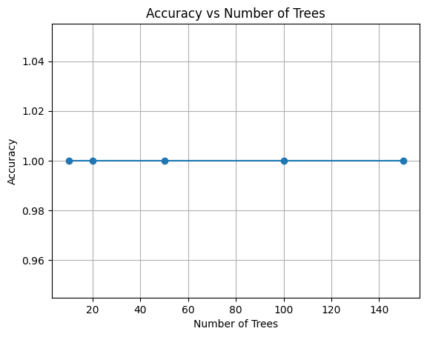
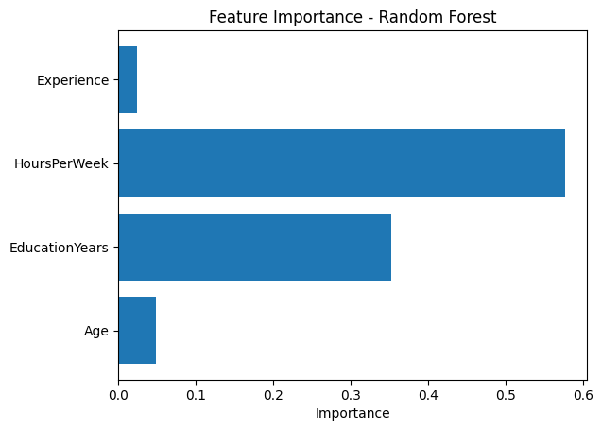
SCENARIO 4: Stacking – HEART DISEASE
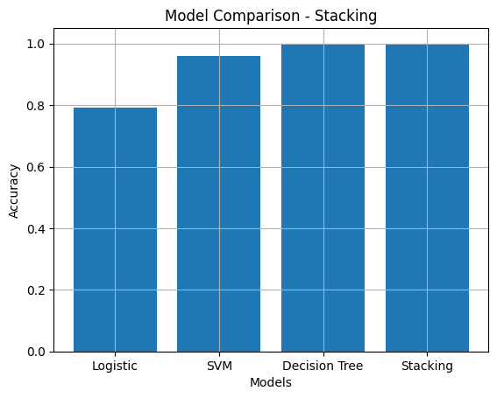
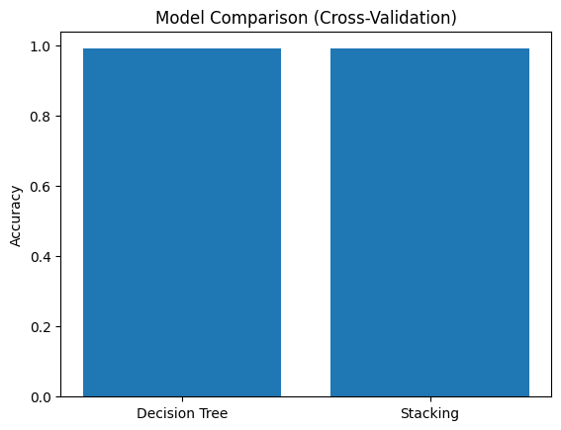

SCENARIO 5: SMOTE – FRAUD
